How to generate Billion dollar products using IDEO?

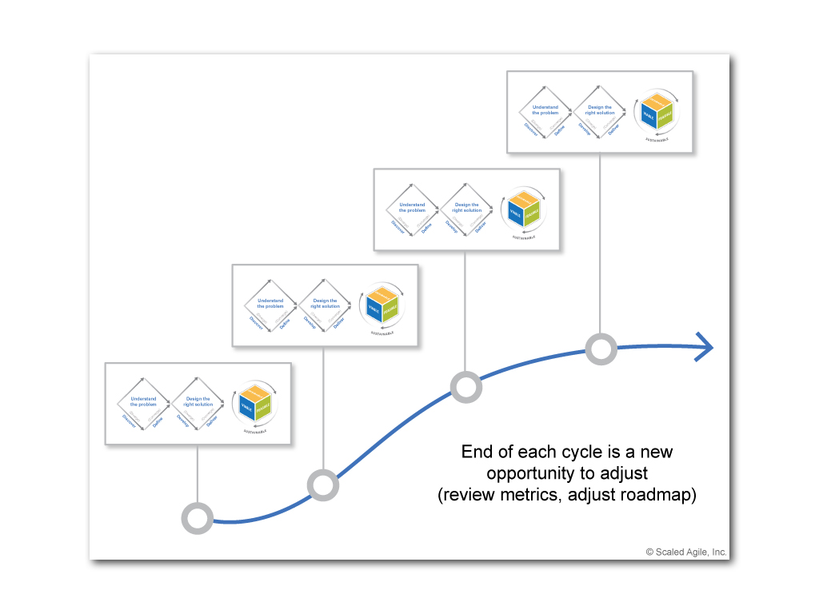

<https://www.ideou.com/blogs/inspiration/11-products-made-using-design-thinking>